Test Project: Virtual To Do List

Goal of the web app is to enable users to organize their tasks. It is a simple table where users have dates on one side and list of tasks on the other side. Users can add/edit tasks, mark them as fixed or not fixed. The app will calculate daily productivity.

All information should be automatically stored in the database on the server.

I created small example in Excel.

Initial situation:

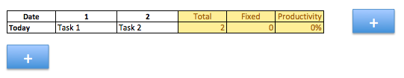

1. First column: shows date. Current day is shown as “today”, not in date format.
2. User can add via “+” button following dates (if he wants to make planning in advance)
3. On next day app automatically jumps on new day and yesterday will be archived under yesterday’s date.
4. In columns 2 and 3 we show example tasks. User can click on the fields and edit the text.
5. Click on “+” button (at the top), adds more task columns.
6. Column “Total” shows nr. of tasks for each day. F. e. today I have 2 tasks.
7. Column “Fixed” shows nr. of tasks marked as fixed. Currently 0.
8. “Productivity” calculates % of fixed tasks (fixed / total)
9. User can mark task as fixed or not fixed via long click. When longclicking on task, small icons appear (similar to this: <http://prntscr.com/azpo64>), check means that task was finished, x means that tasks will not be fixed today. Fixed tasks are marked green, not fixed as red. Empty fields are marked grey.
10. All tasks which aren’t fixed on that day, will be marked as not fixed = red.
11. User can drag & drop task and change their positions.
12. If the text in one field is large and doesn’t fit into standard row, the high of the row should be increased, the font size of the text within the field should be reduced and it will be written in several lines: http://prntscr.com/azqhiu

Another screenshot of the table:

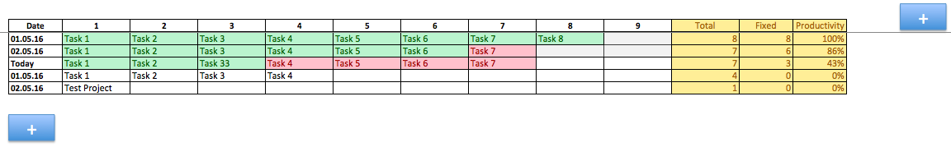

Technologies:

Node.js, React.js, MongoDB

Layout: use some standard template